**PROJECT TITLE**

**SKILL DEVELOPMENT, TRAINING, AND ECONOMIC EMPOWERMENT AMONG WOMEN AND YOUTHS IN NIGERIA**

**Duration**

Five (5) years development plan

**Project Coordinator**

**Agwuna Ebere**

Phone No: +23407035259185

Email: [agwunaebere1@gmail.com](mailto:agwunaebere1@gmail.com)

**Project Members**

**Muazzam Musa Iro**

Phone No: +2347040803758

Email: [auwal1191@gmail.com](mailto:auwal1191@gmail.com)

Skills Development and training is the process of acquiring, improving, and enhancing a diverse set of skills and competencies. It involves the deliberate and continuous effort to build knowledge, expertise, and capabilities in specific areas to meet the demands of one’s work or to pursue personal and professional growth. Earning a respectable livelihood is crucial for an individual’s household to make a living. It is also important to possess the necessary skills that make one employable. For many people, the livelihood skill training program does this purpose. It helps people in learning the appropriate skill and then finding a source of livelihood based on that. One of the major Millennium Development Goals (MDGs) which Nigeria aimed to achieve in 2015 was the eradication of extreme poverty and hunger with the target of encouraging the proportion of people who earn less than a dollar a day to engage in skills acquisition. Skills acquisition is recognized as a vital tool for eradicating extreme poverty and hunger and creating opportunities for job and great wealth, contributing ultimately to the growth of the economy in the country. (Isaac, 2011). Gumbari, a member of the House of Representatives laid emphasis on the pivotal role of skills acquisition, being the instrument in combating hunger and poverty and even reducing crime rates in society through effective engagement of youths.

Nigeria is rapidly expanding her roads network system to improve the movement of goods and services. This requires not only expert and dedicated workers, but skilled technicians that will be able to operate and service the equipment used in road construction. With the establishment of modern industries nationwide, there is a growing demand for skilled and well-trained workers to ensure the quality of goods manufactured in Nigeria matches those produced in developed and developing countries. Despite the global emphasis on women's empowerment, the pursuit of women's empowerment in Nigeria has become filled with rhetoric, lacking sufficient strategies for actual implementation. This is supported by the instance of the successive government which seems to be at loss with unemployment in Nigeria growing at a geometric progression. Unemployment poses a great danger to our society and ailing economy with its attendant social vices plaguing the nation. Unemployment and under-employment of women have been attributed to the fact that most women are ill-equipped with skills for particular jobs (Nwachukwu and Obilo, 2012). Women tends to perform jobs that have minimal skills requirements, and they encounter few opportunities for learning and advancement due to institutional, societal and structural barriers, all of which generates a gender gap in skills development and worsen gender inequalities (Chinen et al.2018).

Even though federal and state governments have engaged different strategies to curb and combat disempowerment, the canker worm seems to have defied them all. However, the utilization of the strategies is not just a matter of providing specific number of jobs, but it is a matter of training women for skill acquisition that will give self-employment and reliance which business education offers the opportunity. Despite rural women major role in agriculture and other rural activities, higher barriers in education and training limit their participation in more productive and remunerative work, perform managerial and leadership roles and participate fully in the development of their communities. Targeted action (in form of training and skills development) is needed to dismantle these barriers (United Nations, 2010). The above thus justifies the need for empowerment for women. Empowering women involves providing appropriate skills, abilities and competences of both mental Empowering women helps bring them into the mainstream of the development process. Women empowerment is understood as a way of developing critical awareness so that women can develop optimally and are able to plan, take initiative, organize themselves, and be responsible for themselves and their environment.

This critical awareness can only be achieved if women are able to look inside themselves and use what they hear, see, and experience to understand what is happening in life (Purnamawati & Utama, 2019). Adetope (2004) expresses that emphasis should be made on the need to empower women to gain economic independence through entrepreneurial development programs, provision of financial assistance as well as various vocational training programmes with a view to bring to limelight and exposing them to different areas of understanding, controlling, and directing their financial values.

**CLASSIFICATION OF SKILLS**

**What is a Skill**?

Mariam Webmaster Dictionary, (2016) defined Skill as the ability to use one’s knowledge effectively and readily in execution or performance; dexterity or coordination especially in the execution of learned physical tasks. Skill is also a learned power of doing something competently; developed attitude or ability of doing a particular task. Furthermore, skills require sustained effort and can be developed or acquired through education, training, or direct experience.

Ali, (2022) classified Skills into two (2), namely: Soft and Hard Skills. Zip job, (2020) and NDE (2019) classified skills into two and further defined them as:

Hard Skills as the Technical knowledge or training gained through any life experiences or Training in either one’s career or education. Examples of Hard Skills are any technical competencies required in any Technical/Vocational Skillsets such as: Fashion design, Carpentry, Electrical Installation, Mechatronics, Tiling, Electronics Repair, Website Design, POP Making Plumbing, Hairdressing Catering to mention but few. These skills can be acquired through the Skills acquisition programs of the National Directorate of Employment.

Soft Skills are personal habits that shape how you work on your own or with others. This is also considered as any practice that can help you to overcome any social or economic challenges that may come your way in life. The soft skills are also referred to as Life Skills, which include Effective Communication, Creative thinking, Decision Making, Leadership, Teamwork and Time Management skills. These training are vital before the commencement of any of the Directorate’s programs, it is aimed at promoting attitudinal/behavioral change among the beneficiaries of NDE programs.

Both the Hard and Soft skills are required in addressing issues of unemployment. In addition, the skills are readily available for acquisition by any interested unemployed persons willing to acquire skills as alternate means of employment, through the NDE programs.

**SKILLS RELEVANT IN NIGERIA’S ECONOMY**

TRAINING IN KNITTING

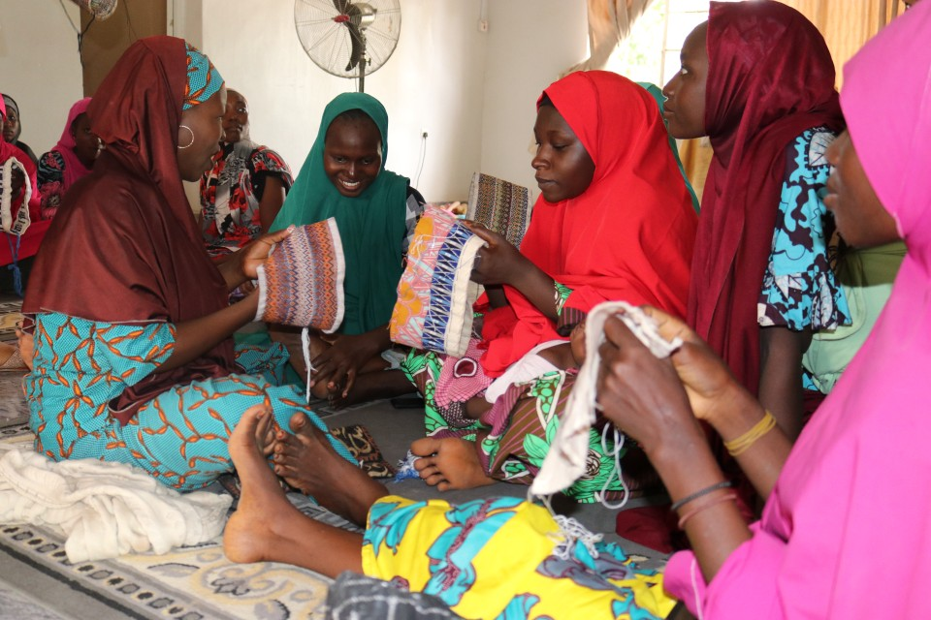

SHOE MAKING AND LEATHER WORK

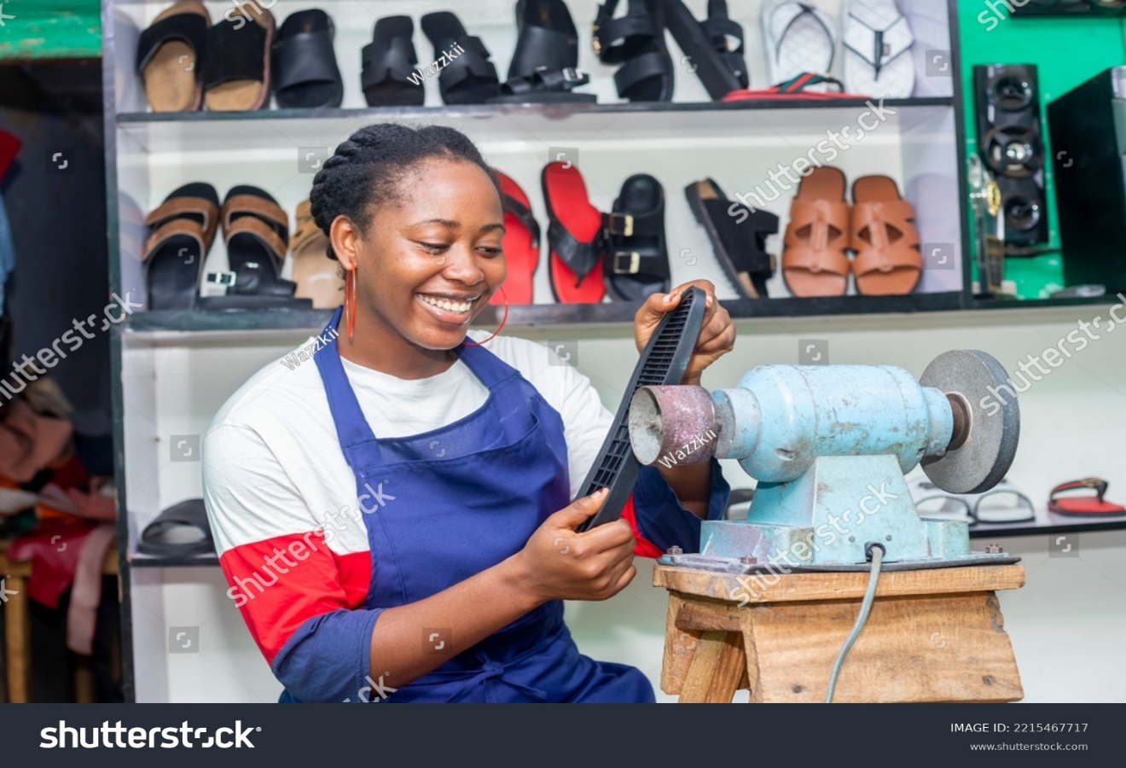

POULTRY

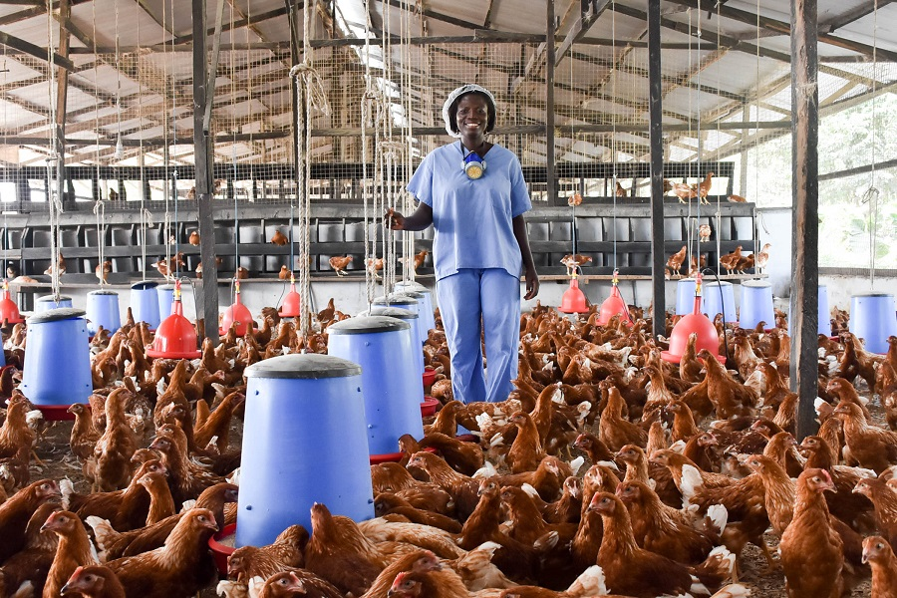

AGRIC EXTENTION TRAINING

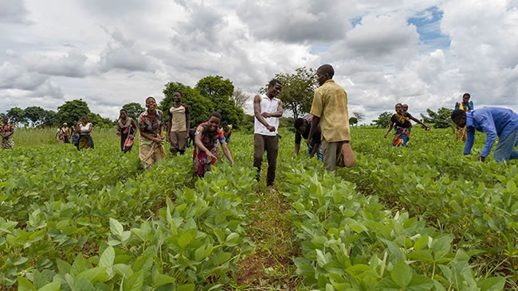

DEMONSTRATION FISH PONDS

TRAINING PROCESSING CASSAVA FLOUR

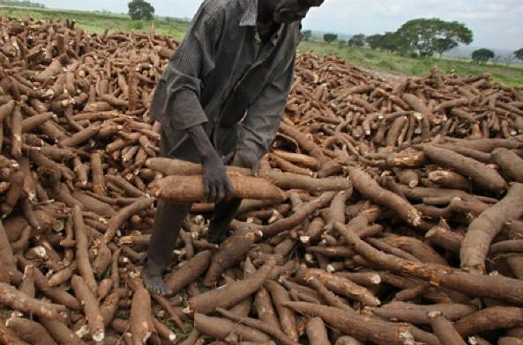

ENTREPRENEURSHIP SKILLS TRAINING

**YOUTH EMPLOYMENT**

The major problem confronting Nigeria Youths today is joblessness. Youth unemployment is a prominent developmental hurdle confronting Nigerian authorities and development stakeholders. These youths constitute greater fraction of Nigeria’s economically active population. According to Awogbenle and Iwuamadi (2010), the statistics from federal bureau

of statistics showed that Nigeria has a youth population of 80 million representing 60 percent of the total population of the country. Also, 64 million of them are unemployed, while 1.6 million are underemployed. This signifies a considerable waste of energy that would have been used to generate revenues and improve the economy of the country. Youths, like other classes of the population have needs to meet (Nnabuife, 2009), but since 1980’s the important roles of the youths have continued to suffer some set back as they can hardly engage themselves in meaningful work (Davies, 2006). The repercussion of this situation manifests in frustration, leading to various vices that contribute to insecurity in the country.

The country suffers jobless growth, expanding population and unemployable youths. Despite decades of relatively consistent economic expansion, Nigeria has struggled to generate sufficient employment opportunities to accommodate its substantial and expanding youth demographic. The persistent high levels of unemployment, particularly among the youth, have been associated with various conflicts and agitation experienced in some regions of the country.

Between 2009 and 2011, the Federal Government deployed the Nigerian Youth Employment Action Plan (NIYEAP) to tackle the challenge of youth employment in the country achieving moderate success. The primary objective was to create a conducive environment for youth unemployment. As the relevance of the Action Plan diminished in the face of changing realities, other policies, such as the National Employment Policy (2017) and the National Youth Policy (2019), replaced it. However, none of these policies has succeeded in addressing the problem in a sustainable manner that would lead to a significant decrease in the youth unemployment rate. According to the National Bureau of Statistics data, from 2014 to early 2020, the youth employment rate was at an average of 25.87 percent.

However, with the rise of the COVID-19 pandemic, by the second quarter of 2020, unemployment rates spiked among all demographics. For the youth, the unemployment rate increased from 40.8% in April-June 2020 to 53.4% in October-December 2020.

**WOMEN ECONOMIC EMPOWERMENT**

Women's empowerment can be defined as a “multi- dimensional social process that helps people gain control over their own lives. It is a process that fosters power in people, for use in their own lives, their communities, and in their society, by acting on issues that they define as important” (Page and Czuba, 1999). In the same way, women's empowerment refers to “women's ability to make strategic life choices where that ability had been previously denied them” (Malhotra et al., 2009). Accordingly, empowerment is central to the processes of maintaining the benefits of women at individual, household, community, and broader levels (Malhotra et al., 2009). It involves the action of boosting the status of women through literacy, education, training and raising awareness (Alvarez and Lopez, 2013). Hence, women's empowerment is all about allowing and equipping women to make life-determining choices across different issues in the country. Another, almost- related and equally important concept in this paper is gender equality. Gender equality is understood to mean that the “rights, responsibilities and opportunities of individuals will not depend on whether they are born male or female” (Warth and Koparanova, 2012). It is also defined as a situation where “… all human beings are free to develop their personal abilities and make choices without the limitations set by strict gender roles; that the different aspirations and needs of women and men are considered, valued and favoured equally” (Holzner et al., 2010). Training of rural manpower is considered one of the most important strategies for ensuring sustainable development. However mostly rural women are underprivileged in comparison to men in their access and abilities to partake in education and training. The result has

been the delimitation of females to have proper access to training and a host of different occupations which in return stopped them from having reasonable and decent incomes and social advancement (UNESCO, 2008).

**Skills and Entrepreneurship – China example**

China had experienced significant skills and entrepreneurship growth in recent decades, and this has positively impacted its economy. China`s economy is one of the fastest growing in the world, with an average GDP growth rate of around 10% for several decades. This development has lifted Millions of people out of poverty and made China the second-largest economy globally. The China success in that regard is not unconnected with the huge investment made on Skills acquisition and Entrepreneurship.

Skills and Entrepreneurship are closely intertwined in China`s economic landscape. Entrepreneurship education in China began in the 2000s. Under the demand of rapid economic growth, the China Ministry of education decided to first launch a pilot stage in nine leading universities across China, such as Renmin University of China, Tsinghua University, and Nanjing University (Zhang,2003) among others. It aims at improving the students’ entrepreneurial ability and competence, instead of just providing professional skills in traditional education. Since the policy of “massive innovation and entrepreneurship” was put forward in 2014, entrepreneurship education has attracted a great deal of attention in China. It is very common to find an entrepreneurship curriculum in a university (Dou, 2019). The data shows that 70.4% of colleges and universities hosted entrepreneurial activities, 66.7% of colleges and universities set up entrepreneurial clubs, and 59.7% of colleges and universities established entrepreneurship practice bases. The China government established strong relationship between the Academia and Practitioner, they commercialized the research findings from universities, through collaboration between the academia and the industries. Example: Alibaba`s Taobao Villages.

Alibaba is one of the China`s tech giants, it has played a very important role in promoting skills development and entrepreneurship in rural areas through its: TAOBAO VILLAGES” initiative. Taobao Villages is just one example of how skills development and entrepreneurship go hand in hand in China. This illustrates how the tech giant leverages its resources to empower individuals in rural areas with the skills they need to become successful entrepreneurs, ultimately driving economic growth and innovation (Wikipedia). Such initiative is not new in Nigeria, for instance, there are schemes that are targeted at rural dwellers eg School-On-Wheels Training Scheme (SOW), Community-Based Training Scheme (CBTS), Rural-Handicraft Training Scheme (RHTS), Community-Based Business Training Scheme (CBBTS), etc.

**SCOPE OF THE PROJECT**

This project, Skill development, training and economic empowerment among women and youths is targeted towards the five (5) southeastern region of Nigeria namely, Imo, Anambra, Abia, Enugu and Ebonyi State in the rural areas. The project will be first implemented in Imo State, before the rest of the remaining four (4) states, where according to the labor force statistics recorded the highest rate of unemployment with 48.7%. The aim is to promote skills acquisition in the rural areas. The focus on sustainability implies a long-term approach, ensuring that the acquired skills have lasting benefits for individuals and the community, fostering resilience and empowerment in rural settings. There is considerable evidence for the marginalisation of rural populations and the incidence of poverty within rural areas. Rural people in general are the most disadvantaged in terms of access to services, including education and training, and are the worst served by infrastructure of various kinds. Rural people are most likely in many settings to be amongst those who are not being reached in the drive towards the Sustainable Development Goals (SDGs). Moreover, such problems are typically starker for rural women and girls, given their multiple burdens. Hence the scope of this study.

**OUTCOME OF THE PROJECT**

This project aims to promote the well-being of the underprivileged and poor population by providing employment and business opportunities, health care, and other forms of support. In addition, these programs aim to strengthen community capacity to manage poverty conditions. Below are some positive outcomes this project promises to bring:

i. Gender Inclusion/Equality: This can also be achieved when women are being provided with skills and training opportunities thereby putting them at par with their male counterparts, which can promote equal gender participation.

ii. Improving existing skillsets: The main goal of skills development and training projects is to empower individuals, especially the women and youth, with necessary skills needed to thrive in the society. This may include improved knowledge, and capabilities in a particular field or industry.

iii. Sustainability: A well-established training programs to ensure that the skills acquired by the participants remains beneficial to them overtime.

iv. Community Development: The skills acquired by the participants can also place them in positions that will enable them to contribute to their communities.